The Founder

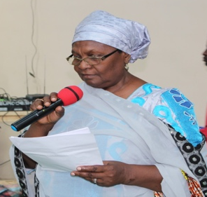
Ms Mairo V. Bello Garko MPH, PhD Candidate
CEO/Project Coordinator

INTRODUCTION

AHIP is a youth-focused Non-Governmental Organization. Established in 1989 as a Youth Club. Restructured and commenced development programs implementation in 1992. The major focus areas are health, social and economic issues as they relate to young people and women. As one of the pioneering organizations on youth development in the Northern Part of Nigeria, it has successfully partnered with international and national development agencies, government at national, state and local levels, Faith Based organization, community-based organization, traditional and religious institutions to establish functional in-and-out-of-school life planning and family life education program. The organization has branches in Kano, Bauchi, Katsina and Jigawa states of Nigeria. Has Partners in eleven other northern Nigerian states (Kaduna, Katsina, Kebbi, Niger, Borno, Yobe, Nassarawa, Plateau, Gombe, Benue and Zamfara.

AHIP has 3 multi-trade vocational centres in the three states of the Northern Nigeria targeting the educationally deprived and economically disadvantage young people. In the same vein, AHIP has a community-based women development program that promotes economic and health empowerment, and currently operating two community based health facilities.

A major outreach effort of the organization is the promotion of information and education of the youth through its basketball team that have all peer health educators as members. They engage in competition with other team in different localities and do outreach education during matchers.

AHIP believes in researching to inform an evidence based design and strategies for program implementation.

AHIP also reach out to young people through the organization’s IN and OUT of school mentoring program.

AHIP contributes to the holistic development of young people and women in Northern Nigeria to compliment the effort of the government of the states.

VISION
Empowering young people and women in Northern Nigeria for improved quality of life.

MISSION
AHIP is committed to provide young people and women in northern Nigeria with information, knowledge and life skills, to enable them make responsible decisions on their health and well-being; working and partnering with other stakeholders.

Core Values
Empowerment and Mutual Respect

GOAL
The organization shall engage in research and documentation; programming and partnership to promote young people and women health, Life skills, social and economic issues as they affect their wellbeing.

OBJECTIVES
Some of the objectives of AHIP are to:
- Research into the condition of young people especially girls, with the aims of improving the conditions of the adolescents in the society.
- Encourage self confidence in growing ladies and men.
- Equip young people with vital information necessary to growing persons in socialization.
- Enlighten adolescents on issues affecting their total wellbeing.
- Sensitize adolescents about knowing their rights in the society and the various laws
- Encourage adolescents especially girls to utilize opportunities in the pursuit of education in all discipline, including vocational training.
- Enlighten adolescents especially girls to grow up to be vocal on issues affecting their mental, physical and social wellbeing.
- Provide knowledge and skills to young people in difficult circumstances
- Provide other services relevant to the wellbeing of young people and women.

STRATEGIES
To achieve the above, the following strategies are employed:

- Engaging with traditional, religious, and community Leaders
- Advocating for policies and Laws that address violence against person, injustice and rights of young people.
- Training and development of young people especially females with knowledge on their right and obligations, leadership and communication skills, building self-esteem, income generating, and entrepreneurial skills etc.
- Integrating health education, social and economic issues.
- Using intensive advocacy to talk and work on difficult issues, human development and Reproductive Health.
- Partnering with other NGOs, CBOS, Faith base organization, and community leaders in building young people’s and women’s capacity.
- Rendering services to young people and women necessary for healthy growth and total well being.

AHIP STRUCTURE
AHIP has its head office in Kano and branches in 3 Northern states of Nigeria in (Bauchi, katsina and Jigawa states) with over 30,000 information sharing members. It has an 11 member Advisory Board made up of 4 trustees and 7 board members. The management Board comprising of key project officers in the Head office, state programme officers, chief Executive and selected supporting staff. The organisation has 45 staff and over 100 volunteers who help in the designing and implementation of programmes.

KEY PROJECT PERSONNEL

The Executive Director/Projects Co-ordinator is a trained Public Health practitioner, Banker trainer, Public Administrator, Sociologist, a trained facilitator, an activist and an experienced mobilisation officer who puts in 70% time to oversee the project implementation, liaison with other actors in the project and the funding organisation.

The Deputy Director Program is an Educationist who has significant leadership and management experience in the development and delivery of high quality program, influencing and humanitarian strategy, with and through partners or directly, in one or more challenging locations. There are Senior Programme Officers in Kano main office engaged to support the Program Managers in operationalizing the different project areas; systems strengthening/capacity building, education and communication. They will provide middle level management support to the Project Managers 100%. And programme Assistants in all the branches and head office.

The Administrative Manager is a seasoned management expert, who has been a trainer administrator and puts in 100% time into the organisation's management, supervision and monitoring of projects, activities and compiles reports. Two additional assistant administrative managers to manage programme and sustainability venture of the organisation. There is an Administrative Assistant in each of the three AHIP branches.

The Account Department is managed by Professional Accountants, a Manager and Assistant manager, and Graduate Accounting Officers. The Account Team manage the project financial resources in line with donor requirements, establish and implement systems including the required control measures that ensure budget discipline and good application of financial resources.
The Monitoring and Evaluation Manager is an expert, who has certified skills in quantitative data management and analysis in relation to monitoring and evaluation of project results against indicators, ability to synthesize and present results of development outcomes using narrative and quantitative reporting procedures, and knowledge of capacity building approaches applied to monitoring and evaluation for government and donor funded projects.
Nurses are employed on full time to work in organisation's youth friendly centres and management of the newly established model clinic in rural areas. Volunteer doctors are also enlisted to work part time the clinics and health centres. Instructors are employed on full time to work in organisation's Institute of Human Development, Kano and all branches.
.

MEMBERSHIPAdolescent Health and Information Projects (AHIP) is designed to address problems of persons that fall within the ages of 9 to 25years. An exception is made however as regards vocational training where persons of 26years and above are trained separately.

AFFILIATION
AHIP belongs to a number of networks visually:
- United Nations Economic and Social Council (ECOSOC).

Civil Society Action Coalition on Education for All (CSACEFA)
- Campaign Against Unwanted Pregnancy (CAUP).

Civil Society For HIV And AIDS In Nigeria (CiSHAN)
- National working group on Adolescent and Young people Health and Development
- The Coalition for Policy Advocacy in Kano (C-PAK)
- LACONDA
- Gender Coalition for Access to Justice (GCAJ)

In addition, AHIP goes into coalition and collaboration with other NGO’s working with young people.

AHIP has partnered with National and State government such as:

Federal Ministry of Health: AHIP as an NGO have been selected by the Federal Ministry of Health to serve on the National Committee for Health Promotion in Nigeria. Working group policy development on Adolescent and Young People Health and Development. Working Group on National Reproductive Health Policy and Strategies.

AHIP has successfully partnered with the States Ministries of Health (Kaduna, Katsina, Kebbi, Zamfara, Borno, Yobe, Gombe, Bauchi, Jigawa, Benue, Kano) to refurbish and equip clinics, especially mother and child health care centres. Some health personnel have been trained to operate clients’ centred facilities in the states. The ministry also provides professionals as facilitators on reproductive health in all the trainings for religious leaders and traditional ruler

Directorate for local governments and Chieftaincy Affairs: Working with this directorate help made working with the traditional leaders a reality. It got us close to the Emirate councils in the various states and gave us access to traditional leaders at the different levels (wards, district/villages and emirates)

Ministry of Education: AHIP collaborated with the ministry to integrate the National Family Life and HIV/AIDS education into school’s curriculum in Kano and Jigawa, also collaborated with them in the various states to select and train principal of school.

Ministry of Health: AHIP have successfully partnered with the various states ministries of health to refurbish and equip clinics, especially mother and child health centres. Some health personnel have also been training to operate clients’ centered facility in the states. The ministry also provide professionals who the facilitators on reproductive health in all the trainings for religious leaders and traditional rulers

Ministry Of Women Affairs and Ministry of Information, Youth and social Development: these ministries are involved in all programs for young people and women which the organization have implemented to date. For instance, the ministries provided the venues and instructors for training female and male peer health educators and vocational skills.

Past and Present Partnership for Program Implementation

International Women Health Coalition (IWHC) has funded some of AHIP’s advocacy work for 6 years (1998 – 2004). The support was to strengthen AHIP’s work to meet its goal of improving young people’s access to reproductive and sexual health information and to provide youth development activities focusing on health, social and economic issues. Of particular importance is AHIP’s advocacy and educational work with religious and traditional leaders, government officials and influential individuals in selected states to become informed supporters of, and advocates for adolescent sexuality and reproductive health (ASRH) in northern Nigerian.

Pathfinder International: Mentored and built the AHIP capacity for a successful organizational change and performance. The Organizational Development that took place between 1995 and 2005 developed AHIP organizational structures and processes that influence worker behavior and motivation. It helped the AHIP organizational learning, knowledge management and transformation of organizational norms and values. It set the organizational climate, organizational culture, and organizational strategies on how the organization identifies problems, plans action, negotiates change and evaluates progress.

THE FORD FOUNDATION: The Ford foundation has support AHIP to tackle socio-cultural and economic barrier to wholesome reproductive health of young people and women in northern Nigeria. By build impactful partnerships with government, CSOs, community based groups, Faith-based organization, civic and political leaders, traditional leaders, religious leaders, media, and other relevant stakeholders to strengthen service delivery and creating enabling environment for integrated services, and empowering young people and women. The foundation also supports the work of AHIP in the areas of Integrating Sexuality Education in schools curriculum, promote sexual and reproductive health and rights, working to combat gender based violence and promote gender justice in and out of schools. Providing information to young people and women. Promoting sports for development and using edutainment to promote sensitive and difficult issues.

MacArthur Foundation: Supported AHIP projects that worked to increase awareness on adolescent health; expand knowledge and provide information on sexuality, reproductive health and rights; provide comprehensive youth friendly services; guidance and counselling services for young people in and out of school; develop integrated skills development program in AHIP vocational training centre; developing young people and to serve as outreach peers educators; Facilitate learning on sexuality education in 150 schools in the three states. AHIP youth friendly centre provide health services for treatment of minor health, STDs, counselling for Psychological and emotional problems; promoted adolescent sexuality and health programs; build capacity of leaders to promote Reproductive Health in Northern Nigeria.
OXFAM Novib: The gap identified in the implementation of RH services in Northern Nigeria since the year 2001 informed the decision of AHIP to organize and sponsor the reproductive health leadership training for RH leaders in 12 northern these states (Kano, Kaduna, Katsina Bauchi, Jigawa, Benue, Gombe, Kebbi, Sokoto and Zamfara) to enhance knowledge and skills in effective leadership roles and styles in promoting positive reproductive health practices, gender equity and making motherhood safer. The trainings were conducted by qualified and experienced network trainers/consultants and AHIP trained trainers. Action plans were developed during the training as guide to implement a culturally and religious sensitive RH interventions with people in the various states.

In 2005, Oxfam Novib/David and Lucile Packard Foundation supported the Leaders for Reproductive Health which aimed at improving the reproductive health situations in Northern Nigeria especially among women and young people; creating an enabling environment for actors in RH/FP program; and providing services in hard to reach areas through leadership consensus building, forming and mentoring groups, providing reproductive health service and integrated leadership development program. The leadership project involves selecting leaders from “all walks of life”, equipping them with reproductive health knowledge, develop their leadership skills, sensitize them on RH/FP and encourage them to form groups and become advocates for RH of women, young people and the family. This strategy was aimed at developing leaders who will promote positive reproductive health in the society. The Leader in RH training started 4 years ago in 2001 and has reached 12 states to date, namely Kano, Kaduna, Katsina, Jigawa, Bauchi, Benue, Gombe, Sokoto, Zamfara, Kebbi, Yobe and Borno. Another objective of this project was to integrate reproductive health service delivery through establishment of model health centers for comprehensive primary health care targeting families in hard to reach areas.

The Integrated Sexual and Reproductive Health and Service Delivery in
Northern Nigeria, a 3 year European Commission/Oxfam Novib supported project which commenced in 2006, aimed at expanding the scope and coverage of an integrated youth sexuality education, reproductive health services through leadership consensus building, service delivery and the appropriation of effective and emerging strategies. The project will focus on 10 states of Northern Nigeria. The target groups include young people both in and out-of-school, women of reproductive age and men, leaders from Governmental and NGOs, media practitioners, traditional and religious leaders, health providers, faith and community based organizations and Non Formal Structures. Key strategies in this project include service delivery through establishment and/or upgrading/improving of community-based Reproductive Health clinics(some of which already exist), training and education of key actors, community outreaches through mobilizations, advocacy and sports, IEC & BCC, community organizing, networking, tri-media (radio, television and print) campaign and People living with HIV/AIDS.

AHIP/COMPASS: AHIP in partnership with COMPASS have carried out some projects together in COMPASS selected states. Improving the health status and quality of education of over 20 million Nigerians through a wide Variety of interventions which included: improving quality of basic education; expand the scope of Reproductive Health/Family Planning (RH/FP) and Child Survival programs

SOUTH_SOUTH Initiative: AHIP was part of a meeting which brought together NGO working on Health and Education in West Africa where a south-south cooperation was born. NGOs from this meeting agreed to work together and share experience within the West Africa Region.

Visionary Leadership Program (VLP): was first launched on the 8th of July, 2003 and was a product of the South-South initiative. AHIP was the anchor institution for the Visionary Leadership Program in Nigeria. The VLP is a program of a consortium of three international organizations. The Partners in Population and Development, International Council on Management of Population Programmes (ICOMP) and Centre for African Family Studies (CAFS), supported by The David and Lucile Packard Foundation. VLP develops leaders and their leadership competencies incrementally through a cost effective South-South Advanced Leadership Training, Mentoring and Exposure Program. VLP also builds capacity for leadership development by creating a learning network of national leadership programs as well as networking influential mentors to reinforce the process of leadership development of participants of the program;

AHIP worked with the Country Coordinating Mechanism (CCM) Nigeria to develop the country’s Global Fund Round 8 Proposals for HIV/AIDS, tuberculosis and malaria. AHIP was also selected as a Sub Recipient of the global funds in Nigeria.

VSO: The link with Voluntary Services Overseas (VSO) got the organization to host a global exchange involving young people from Nigeria and the United Kingdom with 2 volunteers placed in AHIP

AHIP, ENHANCE, NAPTIP and USAID. Collaborated in hosting a forum, which used the findings of studies and conferences report on the almajiri system to highlight the problems of almajiris (street children). It looked at ways to identify streets and tsangaya schools and work in phases to integrate western education and LSS into their system and ways to integrate issues of basic hygiene, HIV/AIDS, life skills and reproductive health issues to conform to the Islamic teachings; strategies of reducing/stopping begging, trafficking and use of almajiris as instrument of sex worker and street hawking and identify training needs for stakeholders on the dangers of child begging in Islam.

PEACED PROJECT: Funded by GCERF. The project is aimed at engaging communities to strengthen the ability of their population to resist conflict, prevent, and respond to communal issues before it escalates, by addressing community need, through advocacy, collaboration, inter-faith engagement, solidarity among civil society, political leader, creative development strategy to provide social education and reintegration of young people back into formal school, develop livelihood skills, counsel for better mental health of young people and women. The project is implemented in Plateau and Nassarawa State.

VOICE 4 CHANGE: Partnered on the DFID-Voices for change program working with young men and women in post-secondary institutions to build their confidence through safe space facilitation and other mentoring activities in order to challenge discriminatory social norms and uphold the principles of gender justice. AHIP has worked with young people in realizing the aim of creating enabling environment for adolescent girls and women in Nigeria.

IPAS: Supports AHIP to do policy advocacy and pursue the adaptation of the Violence Against Persons Prohibition (VAPP) Act in Kano State. To project hold meetings, formed a coalition of civil CSOs, CBOs, Media, Judiciary, law enforcement agencies, relevant Ministries, and built the capacity of the coalition members in legislative advocacy.

AmplifyChange: Work to reduce Gender Based Violence especially rape due to being powerless and voiceless. Partnering with networks and other-stakeholders. Build capacity, strengthen partners to promote laws that will address rape and other GBV in 2 states. Baseline gathering current situation events-and trends, Develop capacity at various levels and tools; develop campaigns & services for survivors; and using multimedia.

AHIP SERVICES TO THE SOCIETY

Resource project-
This consists of the library, research and documentation. The library unit contains specially selected books on growing up issues for both boys and girls. Also available are books on sociology and psychology, this unit has had a lot of young people coming to write their projects and making other researches with the help of the books available.

Video tapes of all AHIP activities like in-school and out-school workshops, vocational center graduations, principals, ward heads, media, partnership trainings and AHIP own recorded drama videos are kept in the resource unit. Also educational films that borders round growing up issues of young persons like yellow card, more time and baby love are also available for the young people.

Research findings on young people behaviors are also well documented .the resource unit has a young facilitator attached to the librarian that helps out in providing the necessary books needed by the users. The resource unit is open from 8am to 5pm from Monday to Friday.
GIRLS AND WOMEN’S EMPOWERMENT
health and development are major goals of the AHIP developmental projects. AHIP employs various strategies in its Young people especially girls and women developmental projects. AHIP focuses on young people, especially girls and women’s’ human rights, reduction of poverty, reducing the disparities in politics, education, and wealth creation. Ensuring young people and women have increased economic capacity and power to bargain in society, while improving social relations, power dynamics, gender equity, and increased engagement as advocates for SRHR, particularly for marginalized groups.

Methodology
AHIP focuses more on young people especially girls as traditionally in the northern Nigeria, girls usually get married at an early age hence putting them at a disadvantage. Most of the girls in the projects are uneducated, unskilled, lacking the ability to make educative or informed decisions or make the right choices in life as a result of their low self-esteem. The different strategies are designed with embedded monitoring and evaluation plans, which encompasses pre and post test, monthly monitoring process and well structured evaluation. The evaluations provided both qualitative and quantitative assessments and analysis of the implementation processes and results inline with project objectives.

Strategies
Girls Assets and Economic Capacity development
These findings following a research done in1994 which showed that there is a pressing need for developing girls and women’s economic generating capacity hence the establishment of a vocational skills training center for married, single girls and divorcees as well as disadvantaged boys.

The students of this Centre are trained in various skills and trades such as tailoring, knitting, soap making, tie and dye, basic interior decoration skills, and home management. Most of the vocational trades require little capital to set. Students at the centre are also equipped with entrepreneurial skills, basic literacy classes (read and write in English and Hausa and also basic Arithmetic), health, and hygiene classes. These classes cover a duration of 3-6 months before graduation and offer certificates after completion examinations. While this program may not take care of all adolescents’ financial problems, it is a step towards economic empowerment and it also provides a conducive atmosphere for AHIP to address reproductive health and other developmental issues.

All participants in the vocational center training must go through a livelihood training in basic health, reproductive health, leadership, communications, gender relations, HIV/AIDS, STIs, problems young people faces, values and decision making, negotiation skills, drug abuse, communication , leadership, goal setting , and career development, emergency care, parenting, puberty management, contraception, finding help, happiness at home, self-esteem and confidence building, and other related issues.

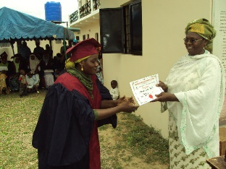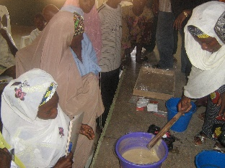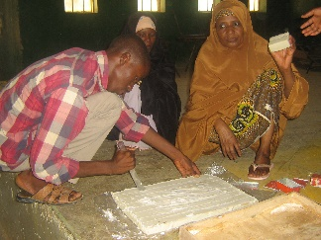
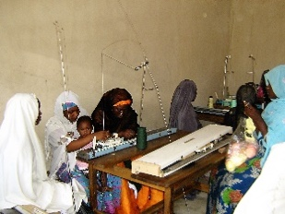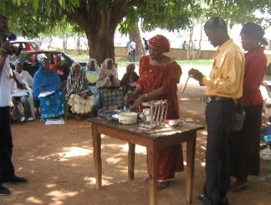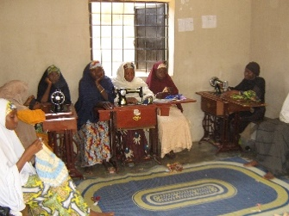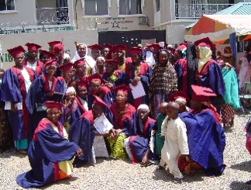

Safe Space (SS) for Social Education
SS program for vulnerable young people in-school and out of school. Girls in ranges of age 10-14, 15-19, and 20-24 are brought together in a segment specific, girl-only platforms in cohorts. AHIP work with them on vital health, rights, and social issues concerning their wellbeing. Each cohort of girls contains 15-20 girl and a trained mentor/facilitator is assign to each cohort. The mentors/facilitators (A respected and trusted person in the community) support and provide guidance to the girls in various sessions of discussion and facilitation in a safe and supportive environment free from violence and abuse. In order to develop girls to improve their live chances and reduce negative consequences in life. The young girls in school are called star girls and seen as role models by their peers.
AHIP is running community based safe spaces for girls’ empowerment. The Project is aimed at increasing girls access and use of health information and services, education, financial literacy and other social services including skills to help reduce their vulnerability to physical and sexual abuse. The benefits the girls stand to achieve through this program include skills acquisition, reproductive health information, enhanced health seeking behavior skills, and access to health services in their community.

Topics in a curriculum that the mentors are trained on and in turn teach the Girls include: Values, Goal Setting, Self Esteem, Gender based Violence, Drug Abuse, all components of Reproductive Health, Communication, and Decision Making, etc. All these are to improve their skills and life chances of the girls. There are some suggested qualities expected of a mentor such as Good Character, Self Esteem, Confidentiality, and Empathy. SS information forms are given to each mentor to fill in order to get the general information for each Safe Space established.

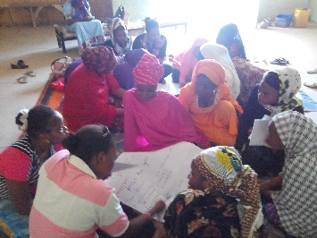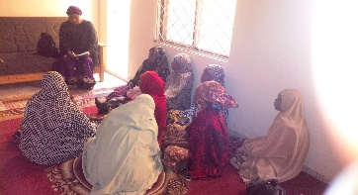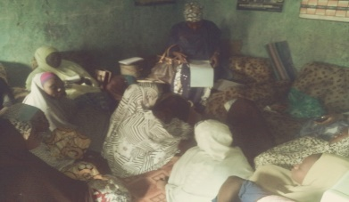

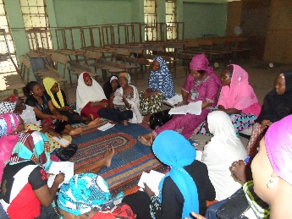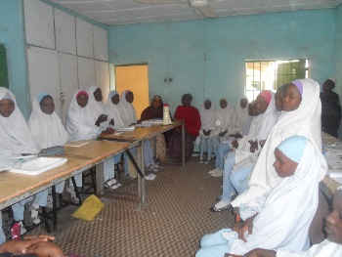

PEACED PROJECT: Funded by GCERF the project is aimed at engaging communities to strengthen the ability of their population to resist extremism and radicalization by addressing community needs, through advocacy, collaboration, inter-faith engagement, solidarity among civil society, political leaders, creative developmet strategy to provide social education and reintegration back into formal school, livelihood skills and psycosocial activitiesfor youg-people and women. The project is implemented in plateau and Nasarawa State.

POLICY WORK PROJECT: Funded by IPAS the aim of the project is to create awareness and to advocate for policy adaptation/adoption, formulation, domestication and implementation including to create awareness on gender based violence including people living with disability(PLWD). The project is implemented in Kano and Bauchi State

V4C PROJECT: Voices for change is a programme funded by DFIDUK aid, working to strengthen and creating enabling environment for gender equality in Nigeria through various activity. it is implemented within tertiary institutions in kano state the aim of the project is awareness creation and sensitization program on gender issues which have helped to change certain beliefs and societal thinking about women and girls. It reaches its target through its Physical safe space, virtual safe space(purple academy) radio drama program called Purple Tinz. Most of the participants (especially female) have been empowered by the Program in terms of decisions making, negotiation skills and networking amongst themselves thereby creating sustainable impact in the area of leadership, communication and management skills. Students that participated(especially females) in the Program
In-School Education: This unit is mainly concerned with disseminating information to the young people that are still in schools with the aim of making them ambassadors in the art of disseminating information to their peers and other siblings. This unit basically disseminates factual information through skillful facilitation sessions at primary, secondary, tertiary institutions and even religious bodies that have youth focused sections in their place of worships. The project also organizes quiz competitions for schools and it reaches an average of 20 schools and 5,000 students per year. The in school unit is managed by two program assistants and all the 12 young facilitators including trained mentors (teachers). Topics addressed in the in-school program includes Self–Esteem; Problems youth face; Values and Decision making; How to deal with dilemmas; Communication; Right steps to adolescents development; First Aid and Emergency Care; Leadership; Organization and organizing; Stress Management; Problems of growing up; Reproductive Review; Reproductive systems and Puberty management; Male Circumcision and Female Genital Mutilation; Gender Roles and Interpersonal Relationship; Parenting; Problems Teenage Parents Face; Predicting Pregnancy Risks; STI/HIV " living with and care for HIV persons; rights and obligations of young people; legal protections.

Out of school project-this project comprises of young people who are all peer educators but belong to different groups like the youth forum, male basketball team {AHIP giants and the Rising Stars}, female basketball team {AHIP queens} the drama troupe, the Community Action Through Sports (CATS) football club and community education.
- AHIP giants, Rising Stars and AHIP queens - this unit is concerned in disseminating information to their fellow young people especially when they are playing matches in the field. They communicate and educate on various health and social issues. Over 500basketball players have been trained as peer health educators on Adolescent Reproductive Health (ARH) as part of the organization’s long-term strategy of building a critical mass of youth leaders to champion a holistic reproductive Health agenda in a sustainable manner. This intervention was aimed at modifying social arrangements and conditions to promote health and reduce risks in specific young people’s contexts,change social norms, institutional cultures and practices that strengthens young people’s voices, leadership and influence over development policies and programs to ensure the promotion and protection of equal opportunities and rights in both the public and private spheres enhancing young people’s abilities to articulate their priorities, organize, and generate collective action to improve their livelihood options and support community development to reduce the gender-differentiated impact of poverty.
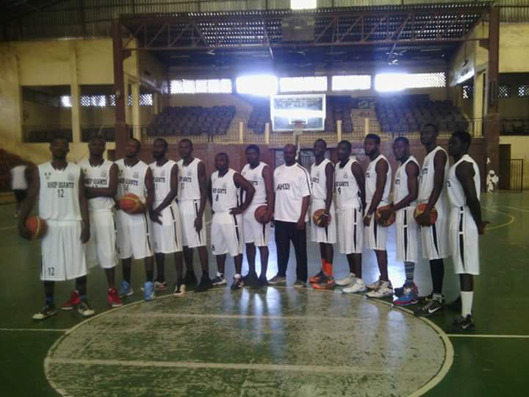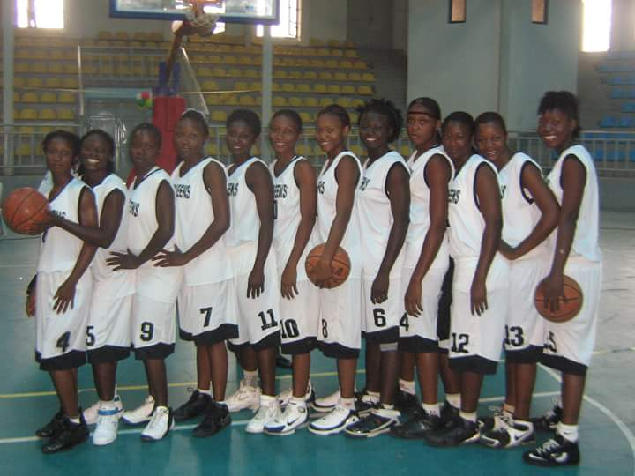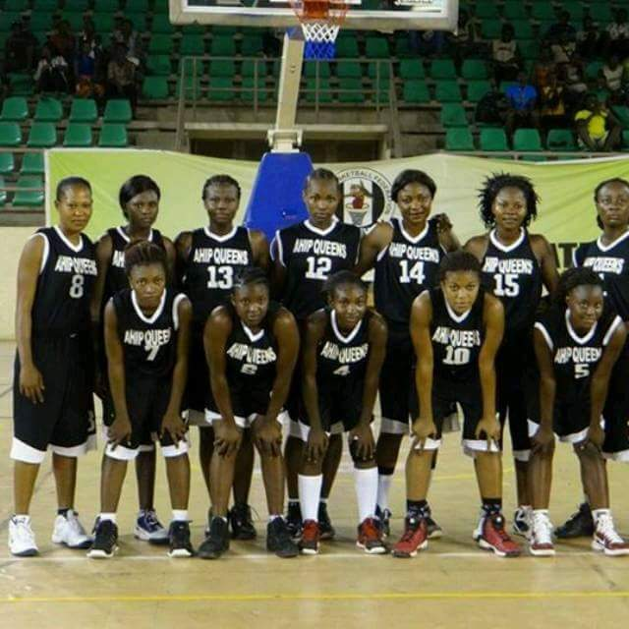

- The drama troupe-just like the saying goes “all work and no play makes jack a dull boy”. Edutainment is a particularly useful strategy that entails the “process of purposely designing and implementing a media message to both entertain and educate, in order to increase audience’s knowledge about an educational issue, create favorable attitudes, shift social norms, and change overt behavior” (Singhal et al., 2004). Edutainment carries an operation on the society to expose the issues surrounding the society and most times profound solutions for the problem(s) if any, and shows or gives way forward in form of drama, film, arts, games and so on. The idea of using edutainment is not an end unto itself, but a means of getting people to talk about the issues, this is why AHIP made it our business to propagate some of the issues in our society at large through the AHIP drama troupe. This unit through entertainment reaches out to the young people by producing educational films that borders on the lives of the young people. The unit also uses young people in the drama to impart positive moral lessons. AHIP’s possible outcome is to create a change in attitude on the issues exposed in drama, the information on a particular issue like, HIV/AID, STI, and Teenage pregnancy is addressed.
- 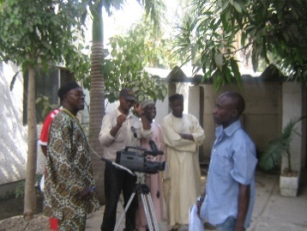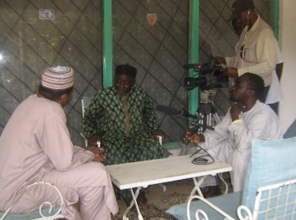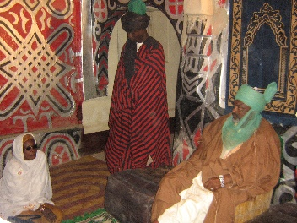
- 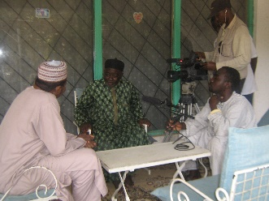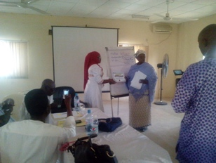
- Community Action Through Sports (CATS) football teams – this unit serves as an outreach team that is set out to empower young people from different community to do community work and use their leisure time productively.
- Social Education: also known as community safe space. This unit is mainly concerned with disseminating information to the young people that are out of schools. The age range is from 12-16 years. This unit basically disseminates factual information through skillful facilitation sessions at designated centers within the community. it reaches an average of 300 young girls every 3months from the selected community. Each community reaches 15young girls per quarter. The community education unit is managed by two program assistants including trained community mentors. Topics addressed in the program includes: Self–Esteem; Problems youth face; Values and Decision making; How to deal with dilemmas; Communication; Right steps to adolescents development; First Aid and Emergency Care; Leadership; Organization and organizing; Stress Management; Problems of growing up; Reproductive Review; Reproductive systems and Puberty management; Male Circumcision and Female Genital Mutilation; Gender Roles and Interpersonal Relationship;; Parenting; Problems Teenage Parents Face; Predicting Pregnancy Risks; STI/HIV; living with and care for HIV persons; rights and obligations of young people; legal protections

The youth friendly services-this project as the name implies is mainly designed for young people and was borne out of the fact that the young people need space and confidentiality when they seek attention to solve their problems. They really need trusted people to talk to and confide in and thus creating a youth friendly and conducive atmosphere is what this unit is mainly concerned in doing. This project consists of 5 major units and they include the following
- Welcoming planet\ orientation bay- this unit is mainly concerned with registering and orienting young people on the major activities undertaken in the organization.
- Friends galaxy- this is attached to the youth friendly clinic, its primary function is to take a brief history of the clients before sending them to the counseling home.
- Counseling home-this unit is highly regarded as it provides guidance and counseling to the young people that have medical, psychological and social problems before referrals.
- Consulting site-this unit prescribes the young people with medical attention and in the case where it becomes necessary it provides referrals to bigger hospitals.
- Treatment room –provision of drugs at a cost recovery rate are found in this unit and also minor ailments are being taken care of there.

Leaders for Reproductive Health project
This project is aimed at the improvement of reproductive health situations in northern Nigeria, especially among women and young people through leadership consensus
building; reproductive health service delivery and integrated leadership development programmes. This involves selecting leaders from all works of life, equip them with reproductive health knowledge, develop their leadership skill and encourage them to form groups, become advocates for RH of young people and the family. This is aimed at developing leaders who will promote positive youth behavior and reproductive health in the society.

TRADITIONAL LEADERS AND THEIR WIVES PROMOTING FAMILY HEALTH

The program started with the leaders in mixed population groups analysing the reproductive situation in their states using the future search technique. The definition of terms and clarification of issues on sexuality, child spacing, reproductive health, and gender was necessary at this point. They were subsequently trained on full reproductive health issues including leadership skills and issues of violence against persons. The use of group dynamics was encouraged and supported as well as step down trainings in their various communities using implementation plans developed by the leaders with follow up monitoring by AHIP.. The training was conducted in 12 northern states (Kano, Kaduna, Katsina, Zamfara, Sokoto, Kebbi, Borno, Gombe, Yobe, Bauchi, Benue, and Jigawa.).

Strategies
The reproductive leaders programme was expanded to take a new dimension of training traditional leaders as advocates and supporters of reproductive health issues in their communities. The trained traditional leaders are expected to disseminate the factual information to their friends, families, and community at large.

Topics addressed at this training includes: Leadership Style, Leadership and Reproductive Health, Reproductive Anatomy and Physiology; Stages of development; Sexually Transmitted Infections/ HIV/AIDS; Gender and HIV/AIDS, Drug Abuse and it’s social Implication; Communication; Child Spacing and Contraception; Communication and Advocacy; Violence against persons; Teenage Pregnancy; Team building and problem solving; Managing change; Planning for social change; Action plan development.

Objective of the training includes:
- To sensitize leaders and their wives on leadership, reproductive health and its components, male involvement in reproductive health; sex & sexuality, STIs, HIV/AIDS, gender and HIV/AIDS, importance of child spacing.
- To form groups among Traditional leaders for advocacy on Reproductive Health (RH) in the state.
- To identify RH issues in the state and develop strategies to address them

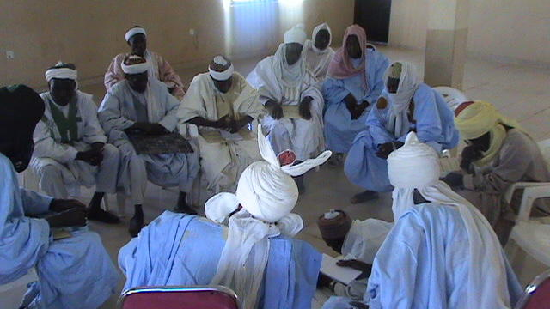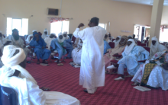

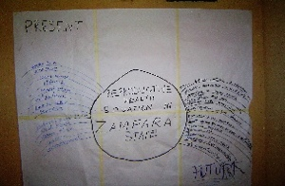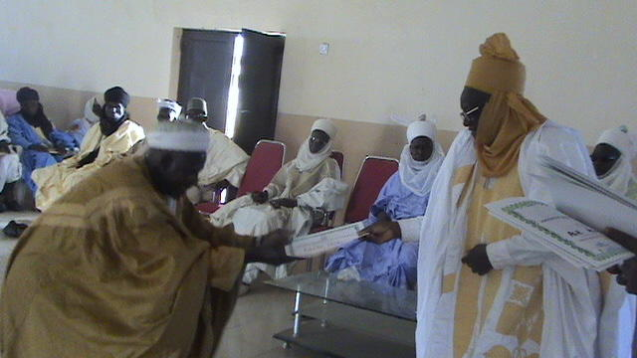

What Has Been Done
AHIP has over time partnered with traditional institutions in Kano, Kebbi, Kaduna, Zamfara, Sokoto, Borno, Yobe, Gombe, Benue, Bauchi, Katsina and Jigawa through advocacy, sensitization meetings and also training workshops on the issues that relate to but not limited to the following:

- Capacity building training on issues relating to the wellbeing of young people especially girl child in the area of reproductive health issues and HIV/AIDS through provision of information.
- Use of advocacy to address difficult issues like reproductive health and life planning skills.
- Sensitise women in the community on the importance of attending antenatal clinics.
- Traditional leaders to work with other policy makers to ensure that people stop selling illegal drugs and campaign for prevention and drug abuse reduction in communities.
- Ensuring that educational facilities and qualified teachers are provided in our schools.
- Using the traditional leaders to inform community members so that men will allow their women to access medical care and services in hospitals.
- Working with other stakeholders to ensure that hospitals/dispensary are adequately equip
- Parents should take proper care of their children, improve parent-child communication and draw them close.

RELIGIOUS LEADERS PROMOTING FAMILY HEALTH

Adolescent Health and Information Project (AHIP)’ contribution to the reduction of maternal and child as a youth focused development organization is to work with Imams in promoting better health and development for young people and their families. AHIP’s major focus areas are development, reproductive health, social and economic issues as it relates to young people and women in Nigeria. AHIP have worked relentlessly to break the culture of silence; create enabling environment for reproductive health, expanded the scope for young people’s health and development, and promoted leadership for integrated reproductive health, service delivery and peaceful co-existence in Northern Nigeria. Hence, the strategic work with religious leaders in nineteen in northern states of Nigeria to promotes Family Health.

The assumption was that the intervention with Imams would lead to attitudinal change towards the health of the family including that of mothers. Starting from the Imams to their followers, families, young people, and other community members. AHIP adopted Social Change Leadership Theory (SCLT) guided by facilitative social change leadership (FSCL). Change here means a switch or shift in the internal and external culture or environment of a social group, organization, government agency, or humanity at large. Since Social change is to bring about or transform conditions to improve the human welfare. Crawford et al (2000) examines Social Change Leadership Theory (SCLT) that is the “what, how, and why” of leadership to create change of personal, organizational, and societal by promoting the development of social change agents who address and solve community problems.
Eminent religious leader, researchers, and medical practitioners presented papers on the planed topics. All papers presented were discussed, the new concept of ‘Open Space’ was also introduced in the last day of each workshop. The ‘Open Space’ technique afforded participants the opportunity not only to introduce their own issues or issue they felt were not adequately addressed in the sessions for discussion but also to be the convener and lead others in the discussion of that topic or issues without any restriction as to topic or number of persons involved. At the end of each training session delegates wrote and adopted a communiqué in which observations were made, and resolutions passed.

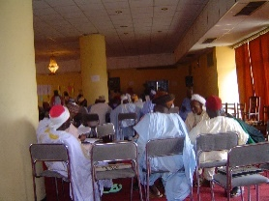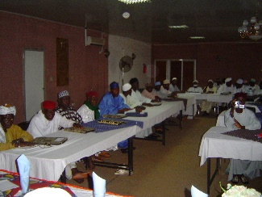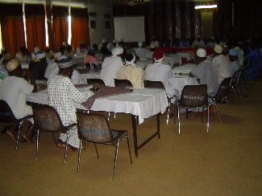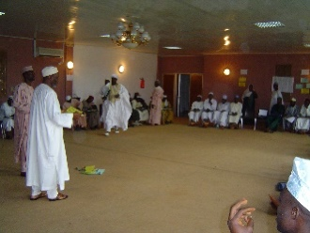
Imams in Training Session
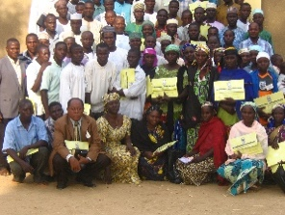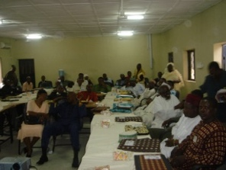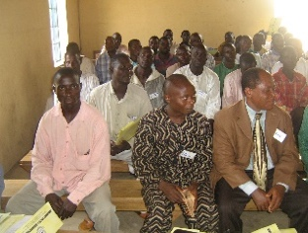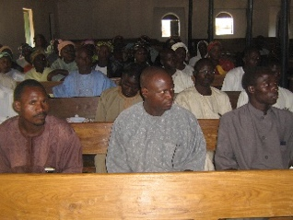
Pastors in training session

THE AHIP LIVELIHOOD SKILL TRAINING SCHOOL EXPANDED ITS ACTIVITIES TO INCLUDE ENTREPRENEUR SKILLS
Empowering young people with life planning and livelihood skills that can help in preventing HIV among young people. The socio-economic vulnerability of young people; particularly those marginalized by gender is recognized as causes of the conditions that put young people at risk of HIV/AIDS. Although governments are desirous of creating jobs for young people, the mechanism to do so has been elusive. AHIP established a livelihood skill acquisition center and integrated peer health, HIV and STI education into the livelihood skills acquisition program of the Institute for human development. The program trains over two thousand and five hundred young people each year. The trained young people are then encouraged to train three young people each. The various trades are ICT; Photography; Video coverage; tailoring; knitting; tie and dye; soap making, pomade making; typing; bags and other crafts of interest; health management; home management; funds management and small business management. The center also engages in advocacy, production and promotion of sales of the centre’s products. The livelihood skill acquisition center produces bed sheets; quilts; veils, cardigans, baby shawls, shawls and some mufflers for children, young people and adults. AHIP through its institute for human development is recruiting a technical team of experts to work out a model for an NGO-government-private sector partnership and collaboration on livelihood options and job opportunities for youths in Jigawa and Kano states.
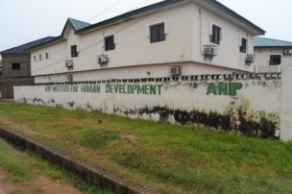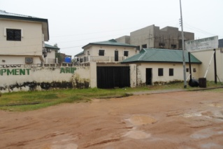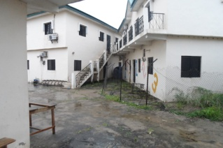
The centre holds her graduation ceremony once every year and it is attended by partners from ministries of health, women affairs, education and directorate of youth development. Student graduated with entrepreneurial/small scale business skills; Video program management; tailoring; knitting; basic computer operation skills; basic literacy; soap and pomade making; tie and dye.

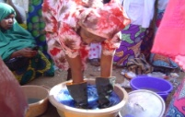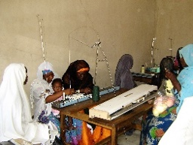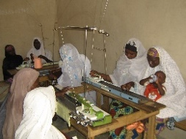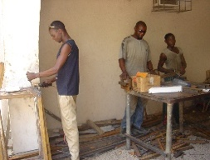

INSTITUTE FOR HUMAN DEVELOPMENT

Institute for Human Development is the capacity development unit of AHIP. It comprises the leadership training, Livelihood skills/vocational training, the day care, and the continuing learning unit.
Training Livelihood Development: The training on integrated livelihood skills development was conducted and 41 participants were trained. Topics addressed at the training were Sustainable livelihood development for young people; the rationale for such intervention; Livelihood framework, Building human capital; Building social capital, financial capital, physical capital, Natural capital, Developmental assets and capacity of local service providers. Assets (external and internal), Challenges, Possible outcome, Strategies, 40 developmental assets; External assets: support, empowerment, Boundaries and expectations, and constructive use of time, Internal assets: commitment to learning, positive values, social competencies and positive identity, Livelihood skills development, Factor conditions, Understanding external context, Conditions to enable livelihood skills opportunities, Demand conditions, Institutional conditions, Industry conditions,

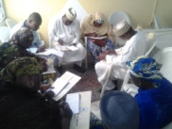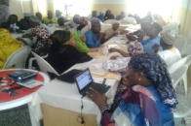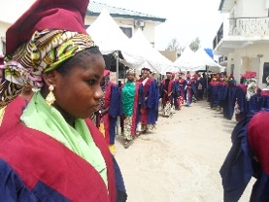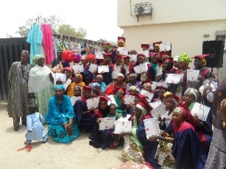

Continuing Learning. The continuing learning initiative is a new addition to the training centre activities. This is a one year remedial class for students, who finished secondary, school but were not able to make their papers.

Day Care Centre Unit. The day care unit, which was meant to serve as kindergarten for AHIP’s staff, has expanded to accommodate children from nearby working class mothers’ children. The unit was equipped and additional Posters and teaching aids provided for the teacher in the centre to facilitate teaching.

Training Professionals and Community-based Health Workers
Systematic training in community development and management skills are conducted for health professionals and those who supervise the operational level, health workers whose responsibility it is to mobilize communities to form committees and to support their functioning and most importantly, for the committee members. Emphasis are given to equity and quality of care issues with particular reference to the health needs of vulnerable groups, such as mothers and young children, who are presently under-served with essential health care.
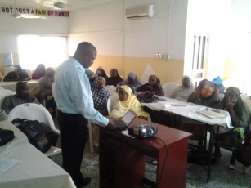

Leadership Training. Are organized and conducted for different categories of leaders: Moslem and Christian religious leaders; youth leaders, health professionals, students, traditional leaders and married adolescents. Topics addressed differ from training to training. Topics for leaders’ training includes Pre-Test; RH Concept & Components; Reproductive Anatomy and Physiology; Stages Of Development/Safe Motherhood; Sex and Sexuality; Reproductive Rights; Child Spacing And Contraception; Child Rearing And Social Implication; Sexually Transmitted Diseases/HIV-AIDS; HIV/AIDS, Drug Abuse and Social Implications; Leadership Roles and Styles; Leadership and Reproductive Health; Team Building and Problem Solving; Team Building and Problem Solving; Gender based Violence; Communication; Advocacy; Managing Change; Managing social change; Mobilization & Networking; Social Mobilization And Networking; Planning; Action Planning; Post-Test; Evaluation.
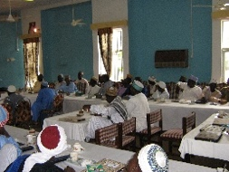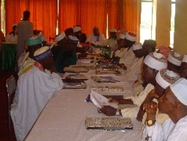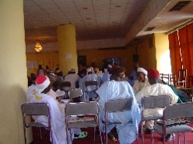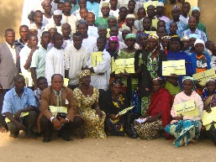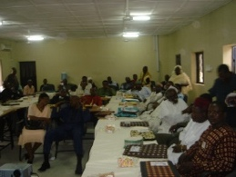

Garko women association project -these women that are based in Garko community formed an association under the AHIP umbrella. They are developed to plan and implement programs to move the community forward. They are involved in production and processing of food crops like rice, groundnut, groundnut oil, and others. They were also trained in how to improve on their existing trade and additional skills were taught them to enable them have additional income generating skills. This we believe will tide them over when the various crops are not in season. AHIP only provided structure, equipment and supervisions.

KEY ACTIVITIES
AHIP have different activities every year for the realization of the organization’s objectives. Some of them are as follows:

- Advocacy-AHIP advocates for the promotion of the socio-economic well being of young people among community leaders, religious leaders and policy makers .The AHIP youth forum also does its share of advocacy to institutions, orphanages, schools and ministries.

- Training & Workshop-AHIP conducts various trainings for different groups of stake holder which includes principals of schools; headmasters; teachers; guidance and counseling teachers; members of the press; traditional leaders; policy makers; youths and youth leaders etc. to create awareness on adolescent reproductive health and its relatedness with problems young people face.
  - Adolescent are also trained as peer health educators in the area of reproductive health
  - Opinion leaders are also sensitized in consultative meetings that bring about meaningful suggestions on how to improve reproductive health standard of young people.
  - AHIP conducts special trainings for drug addicts a
  - Acts as consultants in conflict management training for schools and other parastatals.
  - Train leaders for health

- Carnival of learning- AHIP organizes a carnival of learning every year, creating an avenue for young people to showcase what they gained through the AHIP in-school project. Young people also showcase their talents in other field such as: craft, fine arts, presentations, cooking, barbing to mention a few. This, the organization believes will encourage the young people to develop their God given talent to be used in future for the individual’s livelihood. An average of 20 schools and about 3000 students participate every year, at the end of each carnival the best male and female from the health talk is crowned as the King and Queen of the Carnival of learning for the year and the King and Queen becomes part of AHIP program and works as a young facilitator for other young people.

- Graduation- AHIP sends off an average of 250 students from the vocational training school every year in a colorful ceremony graced by eminent personalities. This is aimed at doing some marketing of the organization, while building the self esteem of the graduating students especially those that may never be opportune to attend or graduate from any form of formal school.

- Sensitization trainings –in order to help the young persons the young facilitators organize a sensitization training once a week, where participants are given factual information on issues like knowing their values, making reasonable decisions, knowing about HIV\AIDS etc.

- Research-AHIP has conducted researches on matters relating to the health and socio-economic factors relevant to and affecting young people. Research conducted include:
  - Situation of NGO’s in northern Nigeria
  - Adolescent Sexual Behavior in Kano state
  - Child survival and sexuality in Northern Nigeria
  - Leaders in productive health
  - Safe motherhood.

Consultancy project
This project entails providing consultancy services like training for other NGOs/CBOs, capacity building, training corporate and private bodies on health issues or conflict management in AHIP training centre or at clients requested sites.
The consultancy department, which has a team of experienced facilitators has been providing services for the past 20years and it has really achieved its aims. We have in the past rendered consultancy services to:
- UNICEF/SFH National Youth Service Corps training.
- Jigawa state youth and AIDs prevention, Gumel, Jigawa.
- BAOBAB
- Action Aid Nigeria
- Churches and Mosques
- WRAPA

